Transition Plot in R, when we have quantitative data for change in time, visualization is straight forward but in the case of a categorical variable, it’s not as easy.

In this article, we are going to describe transition plots for categorical variables.

**Approach 1:-**

You can use plotmat function from the diagram package.

If you are not installed, let’s install the package.

install.packages("diagram")

library(diagram)

plotmat(transition_matrix[1:3,1:3])

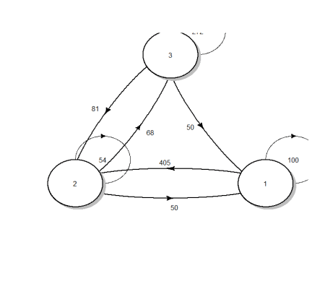

**Approach 2:-**

Let’s load the package transition plot function from Gmisc package.

library(Gmisc)

library(grid)

Let’s create a matrix for visualization,

no_boxes <- 3

transition_matrix <- matrix(NA, nrow = no_boxes, ncol = no_boxes)

transition_matrix[1, ] <- 200 * c(.5, .25, .25)

transition_matrix[2, ] <- 540 * c(.75, .10, .15)

transition_matrix[3, ] <- 340 * c(0, .2, .80)

transition_matrix

[,1] [,2] [,3]

[1,]  100   50   50

[2,]  405   54   81

[3,]    0   68  272

Let’s load the transition plot function and fill the box names

**Transition plot in R**

transitionPlot(transition_matrix,

               box_txt = c("First", "Second", "Third"),

               type_of_arrow = "simple",

               min_lwd = unit(1, "mm"),

               max_lwd = unit(6, "mm"),

               overlap_add_width = unit(1, "mm"))

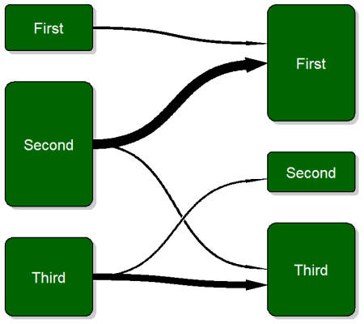

Based on a transition plot function, visualizing time change is quick and provide more intuitive understanding. The lines indicates the transition from one particular group/level into the next.

library(RColorBrewer)

output_perc <-

  function(txt, n) sprintf("%s\n[%.0f%%]", txt, n)

box_txt <-

  cbind(mapply(output_perc,

               txt = c("First", "Second", "Third"),

               n = prop.table(rowSums(transition_matrix))*100),

        mapply(output_perc,

               txt = c("First", "Second", "Third"),

               n = prop.table(colSums(transition_matrix))*100))

transitionPlot(transition_matrix,

box_label = c("Before", "After"),

               box_txt = box_txt,

              cex = 1.2,

          type_of_arrow = "simple")

You can add title while using **main,** box labels based on **box_label**, and customizing box text can using **box_txt**. The box_txtvector assumes the same text or label for both left and right boxes.

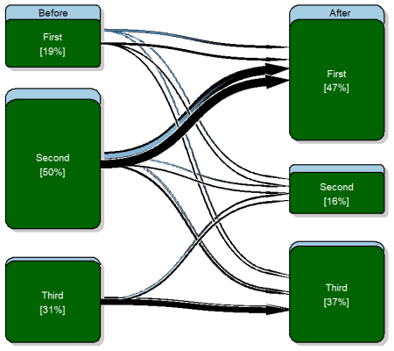

**Conclusion**

The function transition plot is from Gmisc-package and it’s very handy when we need categorical time change visualization.